Wireframe Document

Big Mart Store Sales Prediction

|  |  |
| --- | --- |
| Written By | Vijaykumar Rewate |
| Document Version | 0.1 |
| Last Revised Date | 25.5.2023 |

1. Introduction
   * Purpose: This document provides a visual representation of the user interface for the Big Mart Store Sales Prediction system.
   * Scope: The wireframes cover the main screens and interactions involved in the user input and prediction process.
2. Wireframe Screens

2.1 Home Page

* + Description: The landing page of the application.
  + Components:
    - Logo: Display the logo of the Big Mart Store Sales Prediction system at the top-left corner of the page.
    - Navigation Menu: Include a navigation menu with options such as Home, Sales Prediction, Model Training, About, and Contact. This allows users to easily navigate through different sections of the application.
    - Search Bar: Provide a search bar where users can search for specific products, stores, or any other relevant information.
    - Featured Products: Show a section featuring a selection of popular or recommended products. Include their images, names, and corresponding sales predictions.
    - Sales Overview: Display an overview of the sales performance of different stores or categories. This could include charts, graphs, or key metrics to give users a quick understanding of the sales trends.
    - Latest News: Include a section for the latest news or updates related to the Big Mart Store Sales Prediction system or the retail industry in general.
    - Call to Action: Include a call to action button or section that encourages users to explore further, such as "View More Predictions" or "Explore Store Performance."
    - Footer: Display a footer section with additional links, copyright information, and social media icons for sharing or connecting with the system on various platforms.

2.2 Sales Prediction Form

* + Description: The form where users can input the required information for sales prediction.
  + Components:
    - Input fields for:
      * Item Identifier
      * Item Weight
      * Item Fat Content (dropdown or radio buttons)
      * Item Visibility
      * Item Type (dropdown)
      * Item MRP
      * Outlet Identifier
      * Outlet Establishment Year
      * Outlet Size (dropdown)
      * Outlet Location Type (dropdown)
      * Outlet Type (dropdown)
    - Submit button

2.3 Sales Prediction Result

* + Description: The page displaying the predicted sales based on user input.
  + Components:
    - Sales prediction result
    - Back button to return to the sales prediction form

1. Wireframe Mockups
   * Home Page Wireframe Mockup

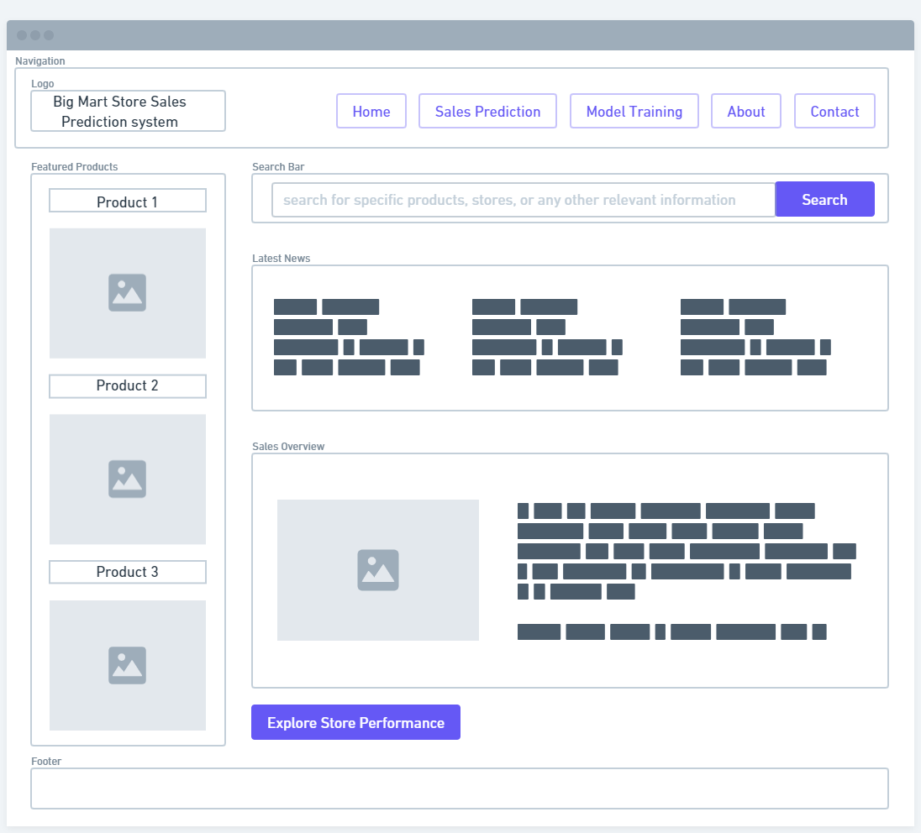

* + Sales Prediction Form Wireframe Mockup

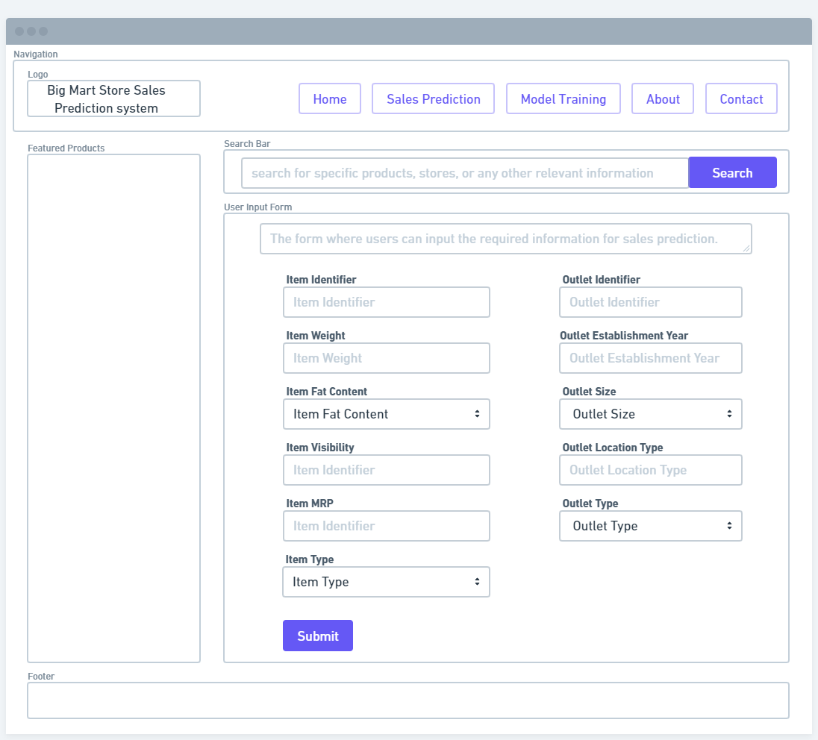

* Sales Prediction Result Wireframe

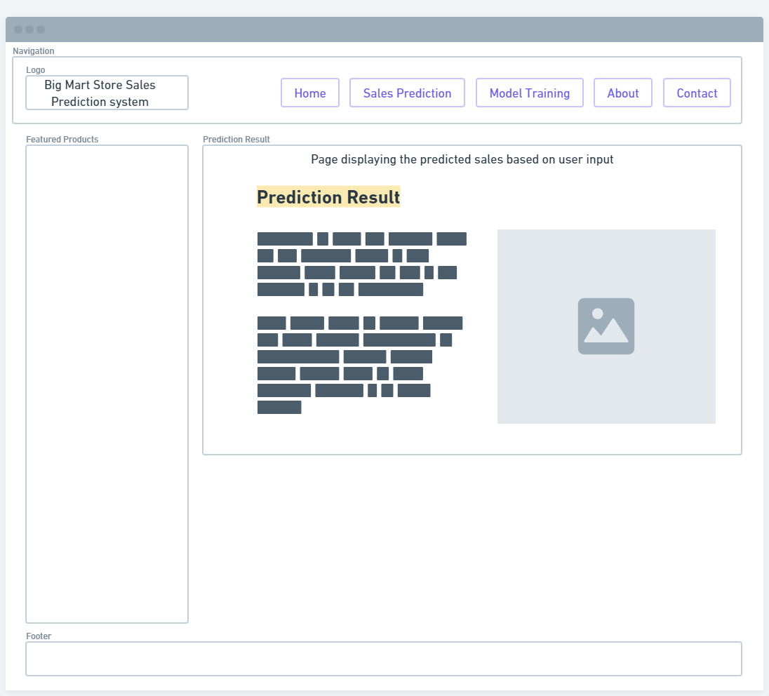

1. Interaction Flow
   * User starts on the home page.
   * User navigates to the Sales Prediction Form.
   * User enters the required information in the input fields.
   * User submits the form.
   * The system processes the input and displays the Sales Prediction Result.
   * User can go back to the Sales Prediction Form to make additional predictions.